# How to connect to the database in OTC cloud (in Windows)

**Description :** This procedure describes how to connect tot he OTC database which was deployed in a private subnet which means it is not publicly available.

**Prerequisites :**

1. Windows 10 or higher
2. Having putty client installed (<https://www.chiark.greenend.org.uk/~sgtatham/putty/latest.html>)
   1. Download <https://the.earth.li/~sgtatham/putty/latest/w64/putty.exe>
   2. Download <https://the.earth.li/~sgtatham/putty/latest/w64/puttygen.exe>

Note : Make sure these 2 utilities are your current PATH (e.g. /Users/<username>)

1. Having Microsoft MSMS client installed

**Procedure :**

**STEP 1 : Create a Public And Private Key pair in puttygen utility**

Link : <https://devops.ionos.com/tutorials/use-ssh-keys-with-putty-on-windows/>

Section in link : «Create New Public And Private Keys» fot the details

You need to save locally the private key on your Windows laptop

and provide the public key (copy/paste) to DevOps Team (e.g. Noel ☺ )

The DevOps Team will add your public key to the server.

**STEP 2: Connect to the server via putty**

Link : <https://devops.ionos.com/tutorials/use-ssh-keys-with-putty-on-windows/>

Section in link : «Connect To Server With Private Key» for the details

and in Session enter the servername in the Host Name field (1)

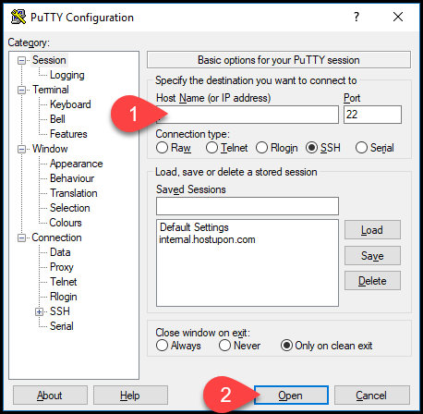

1. The server for OTC is : 80.158.55.12

If you click (2) Open session Button, it will open a terminal to the server

with a login prompt. Enter here the user **ubuntu** and it will login you to the server

After successfull login you can type exit and it will close the window.

Now you can proceed with the next steps. If STEP 2 does not work, don’t waste

your time trying to execute STEP 3 as this will not work. Ask help from the DevOps team instead.

**STEP 3: Open the tunnel connection via putty**

Link: https://electrictoolbox.com/putty-create-ssh-port-tunnel/

Section in link: «Creating an SSH tunnel with PuTTY» for the details

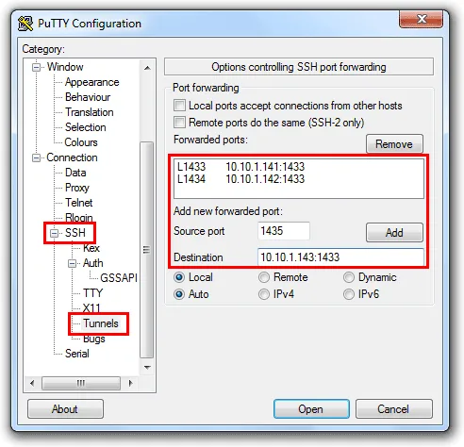

The above screenshot is not the actual configuration, it is just an example.

The configuration needed:

Source port : 1433

Destination : 10.150.2.128:1433. (this is for OTC production DB)

and 10.150.2.218:1433 (this is for the OTC STAGING DB)

and in SSH make sure you have ‘Don’t start a shell or command at all» selected:

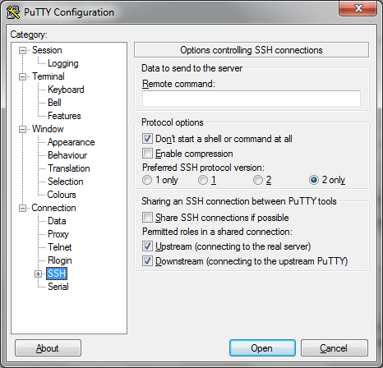

and lastly in Session enter the servername in the Host Name field (1)



1. The server for OTC is : 80.158.55.12

Now you can press the Open button to open the Tunnel session.

This will prompt you for a login. Enter here the user **ubuntu**

After entering the user, It will deisplay a message something like:

«Authenticating with public key «rsa-key-200202»

Leave this session open, otherwise the tunnel will be closed.

**STEP 4: Final step : Connect via SSMS tot he database**

Server name: 127.0.0.1

Authetication: SQL Server Authentication

Login : rdsuser

Password : <contact DevOps Team>

Ans that’s it ☺

